** Transformational Volunteer Mission** [**www.serve-intl.org**](http://www.serve-intl.org) **E. ARNOLD REINIKKA, PROJECT DIRECTOR**

**25 Wood Lane, Malvern, PA 19355**

**610 644 3871 [arnoldre@verizon.net](mailto:arnoldre@verizon.net)**

**SHORT TERM MISSION TRIP TO PERU**

**NOV. 2ND - NOV. 14TH**

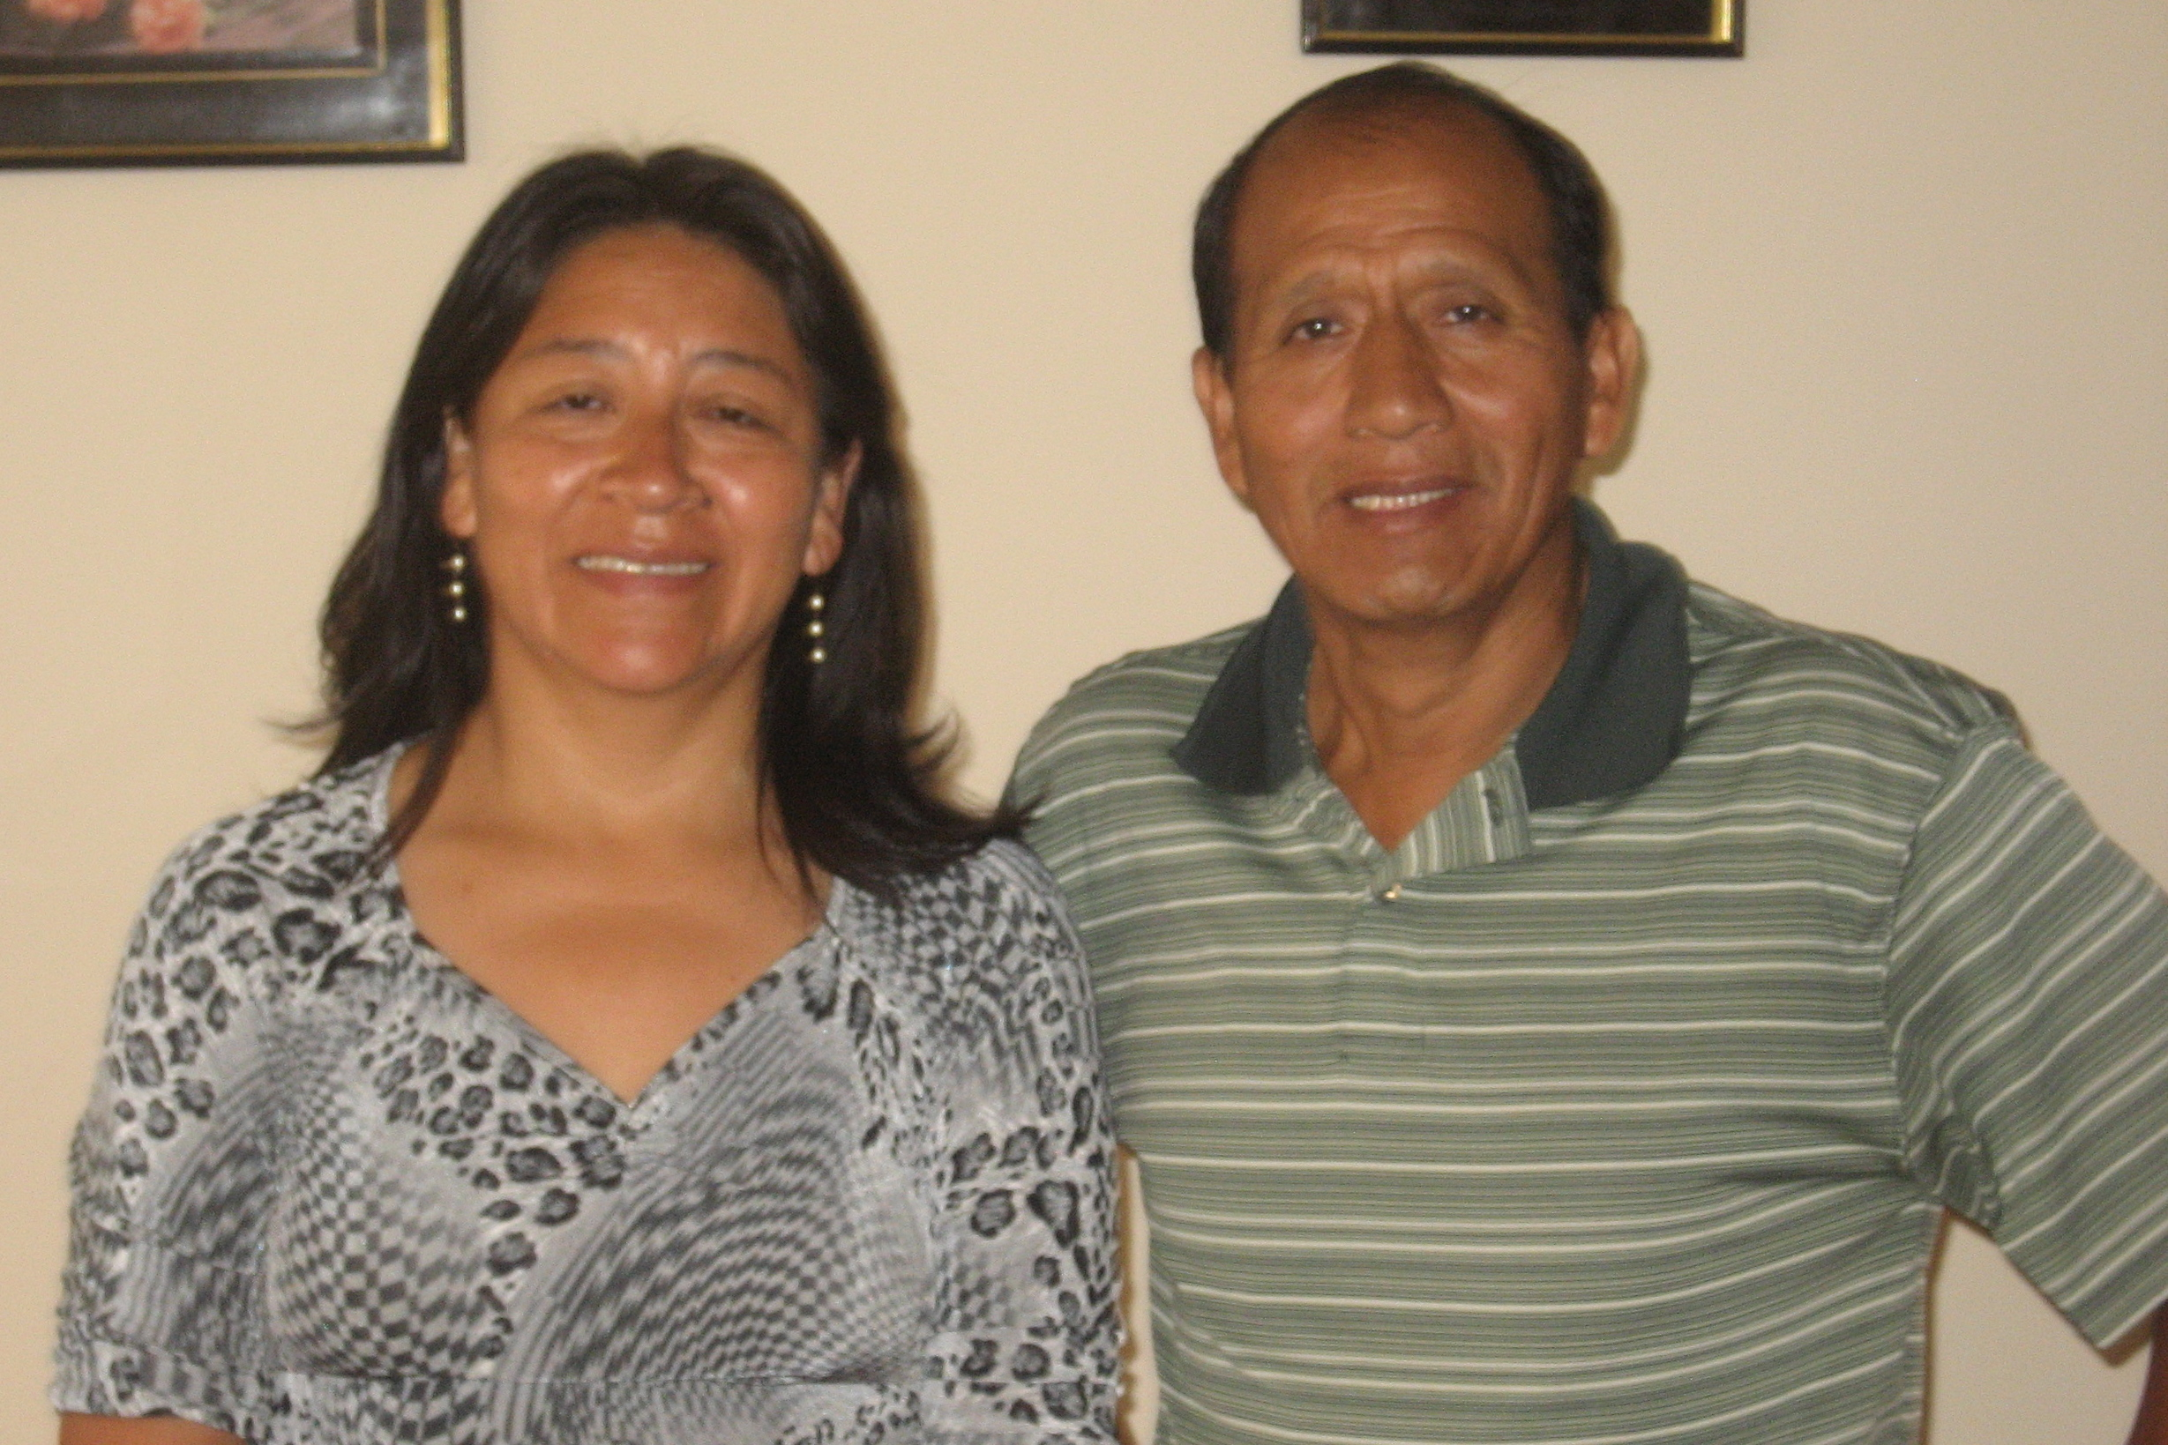 A six member team led by Arnold Reinikka is going to Peru in early Nov. to work with evangelical Quechua mission people associated with Runa Simi. This is an organization we have supported several times primarily performing construction activities along with medical mission work in their main center in Chosica. This is a city about an hours drive east of Lima. This time, at the request of Pastor Samuel Saccsara (leader of the spiritual work in Runa Simi – see Samuel along with his wife Rosa in the photo), we will be assisting him and his wife in performing both evangelical and medical mission work primarily in the Ayacucho area where they also have a mission center. Ayacucho is located in the high Andes Mountains at an altitude of approximately 10,000 ft. Evangelical work will also be conducted with lay pastors in the Chosica area the last two days of the trip. Activities in both locations are planned for both Quechua males and females.

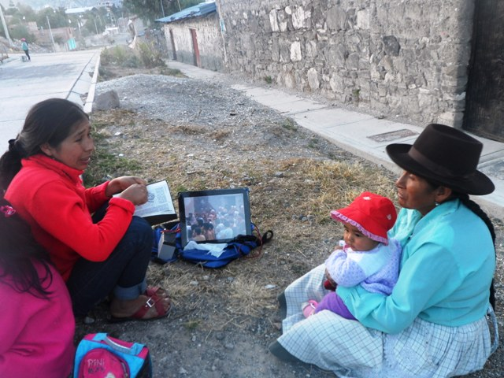Their key mission in Ayacucho is to train Quechua leaders to take the gospel to remote villages and communities in the Quechua speaking areas in the Ayacucho area. Realizing that this is an oral society where most of the elder Quechua’s are illiterate, the Christian leaders use videos of the Gospel of Luke and the book of Genesis in the Quechua dialect of that area to explain the gospel to them. They have performed great work evangelizing and discipling new believers using this approach (photo shows a Christian leader explaining one of the videos to a Quechua lady). Many new house churches have been started in villages where there is no church. Many are coming to Christ and sharing God’s word with others.

For example, in the village of Tirincavine located near Ayacucho the whole village saw the Luke video and everyone prayed and received Christ as Savior and Lord and committed themselves to love one another and work together and build a church. They also want someone to come and teach them more of the word.

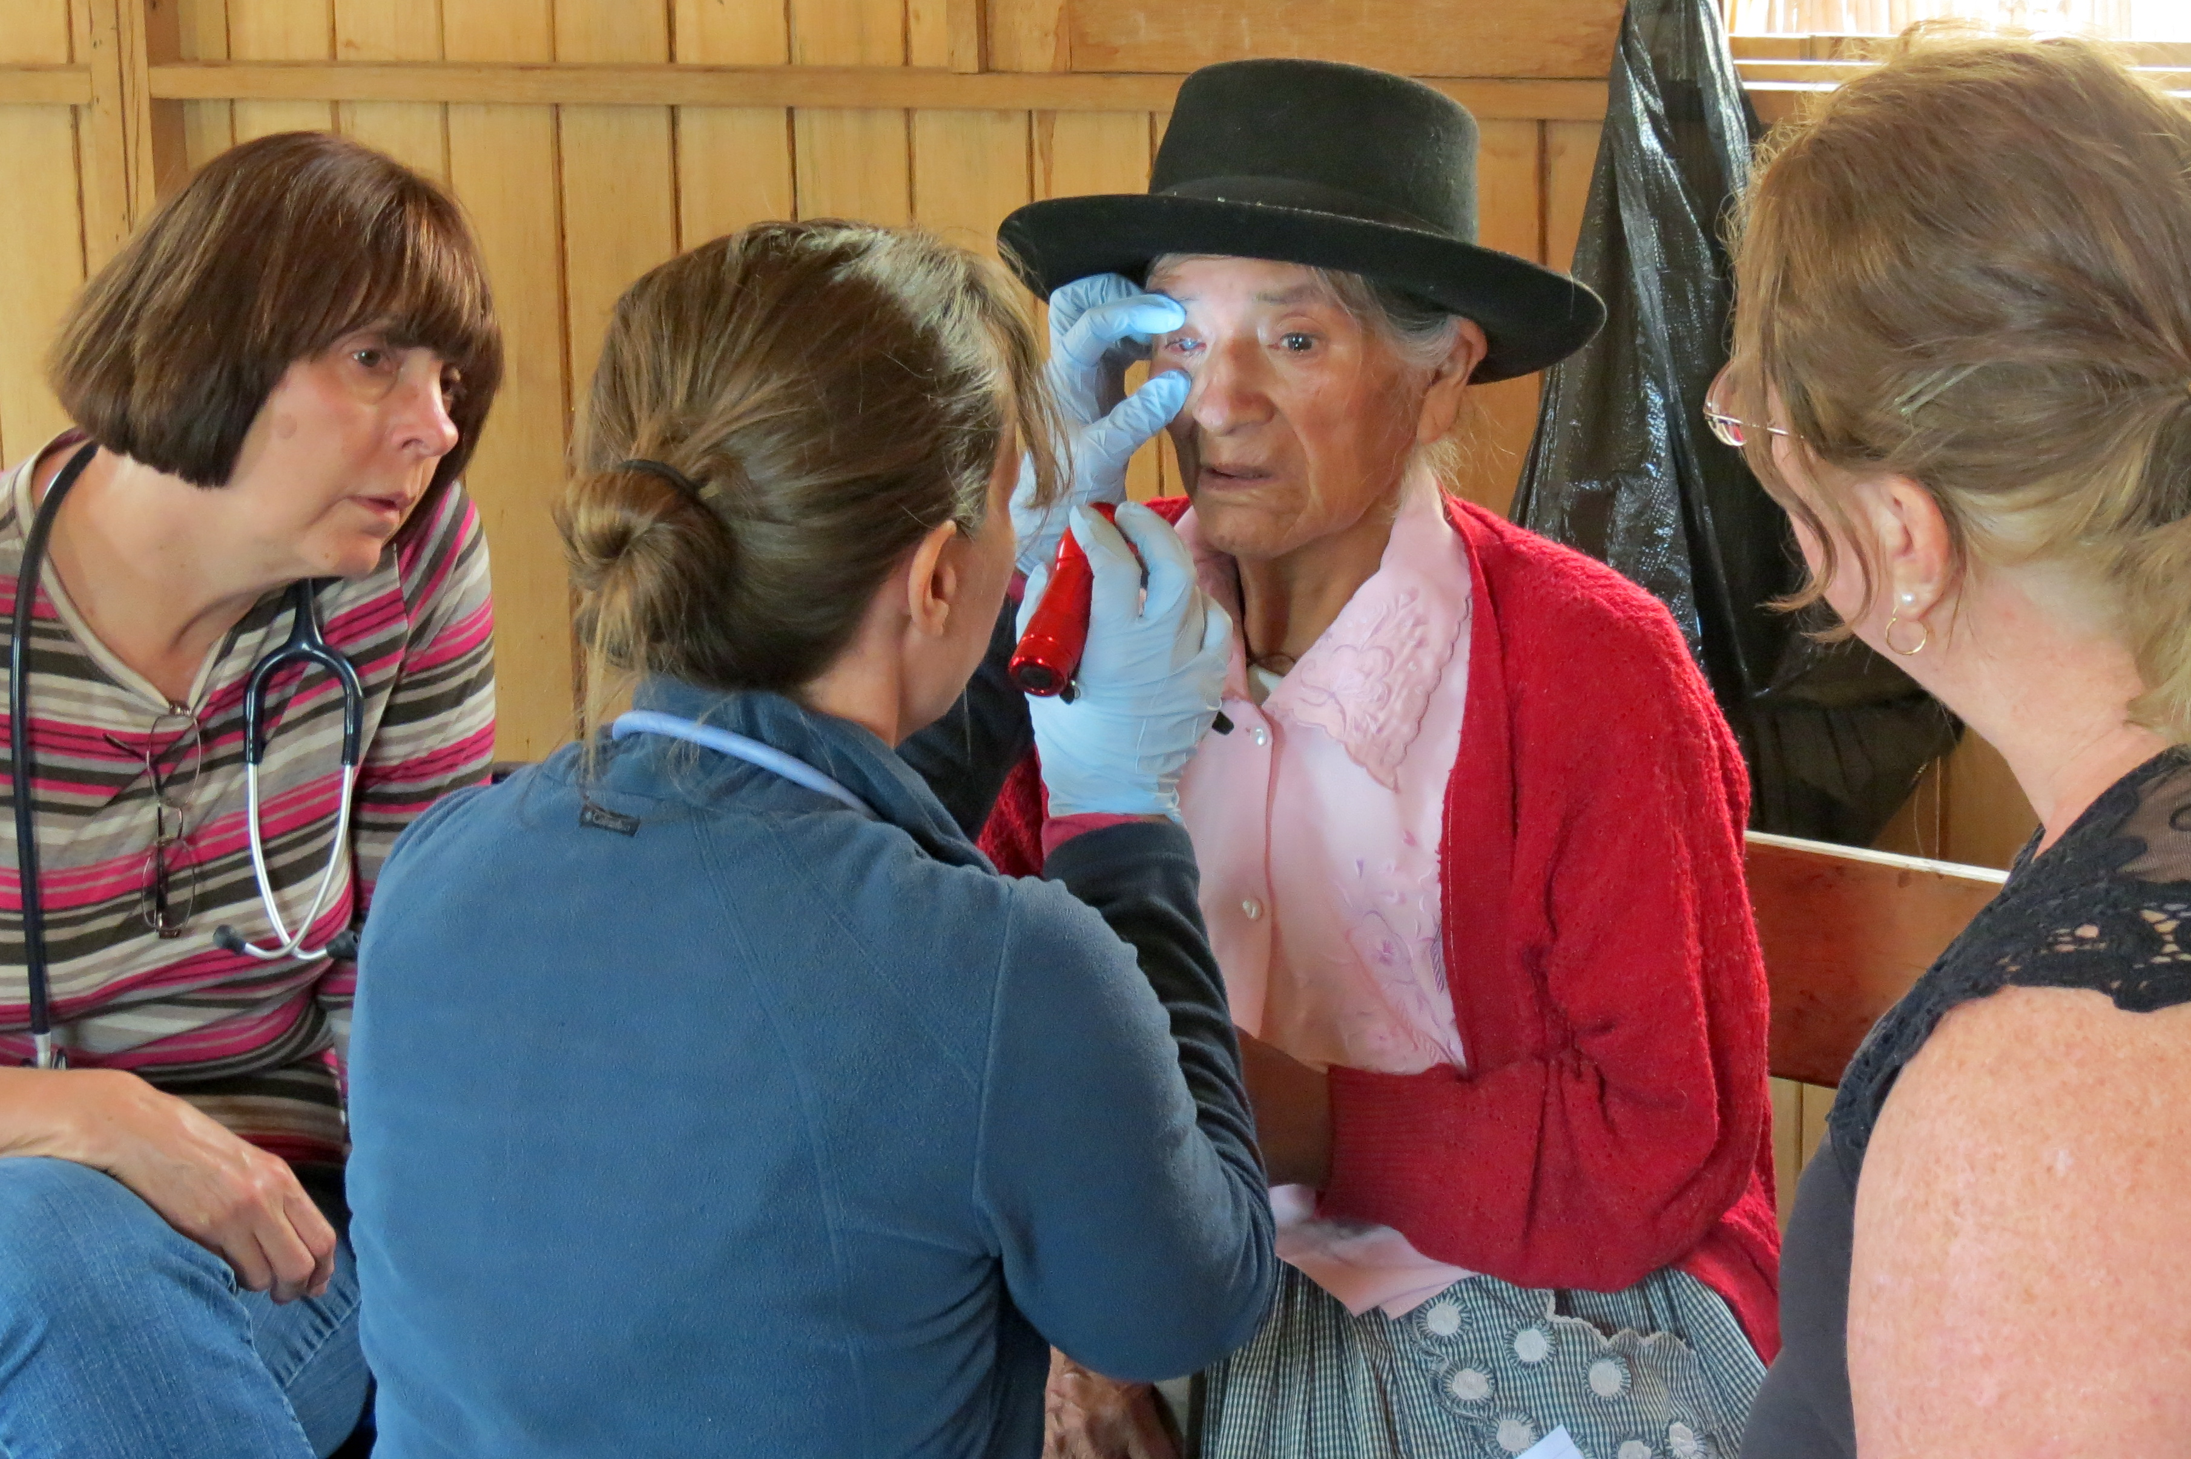Our activities in the Ayacucho area are being planned in two villages and in their training center in the city. Rev. Paul Toms will lead our support of Pastor Saccsara in all of the evangelical activities. Sue Toms (Rev. Toms wife) will be leading our support of Rosa in the women’s ministry. Evangelical work in the training center in Ayacucho will be over a three day period where lay pastors (many will have walked long distances to get there) will be taught the scriptures. It is anticipated that there will be about 50 in the group of lay pastors.

Dr. Ginger Wiley, who performed medical work there two years ago, will lead the medical mission activities (photo shows her examining a patient). She will be supported by Maureen DeGrange who will assist in the medical activities and Donna Reinikka who will entertain the many children who come along with their mothers for medical examinations. Most of the Quechua’s in the high Andes have never been examined by a doctor. We have been told that they are eagerly looking forward to being checked out by Dr. Wiley.

Medical supplies will be provided by Kingsway Charities Inc. International in Bristol, VA. They generously supplied us free medicine for many years but recently they have had to start charging a relatively small fee. **This year it is anticipated that the medical supplies will cost about $2,000. Donations are needed to purchase these needed supplies. Please send funds to SERVE at the above address with a notation for the Peru Trip. Thank you.**

E. Arnold Reinikka, Project Director

SERVE is incorporated in Pennsylvania as a 501c(3) non-profit organization by the IRS. Donor gifts are tax-deductible

No gifts or services are received from donations to SERVE